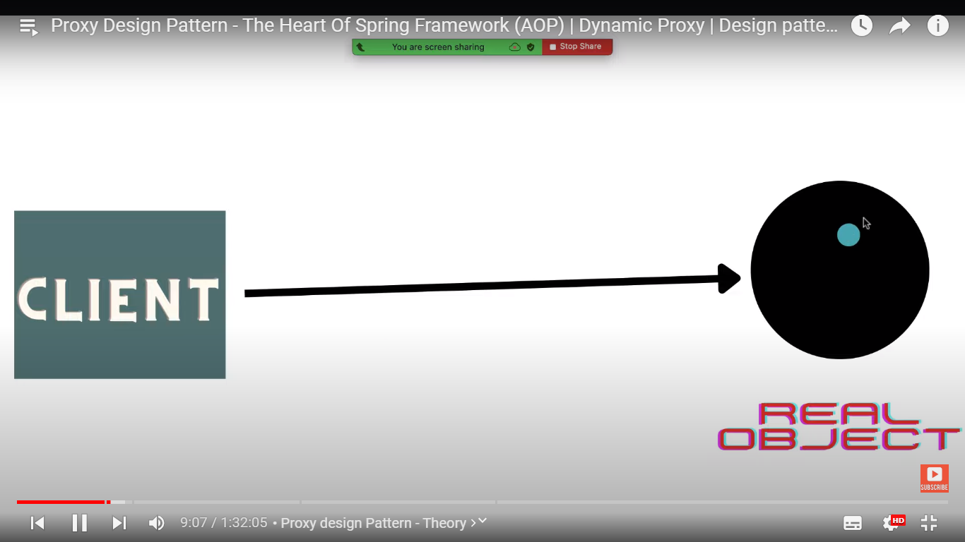

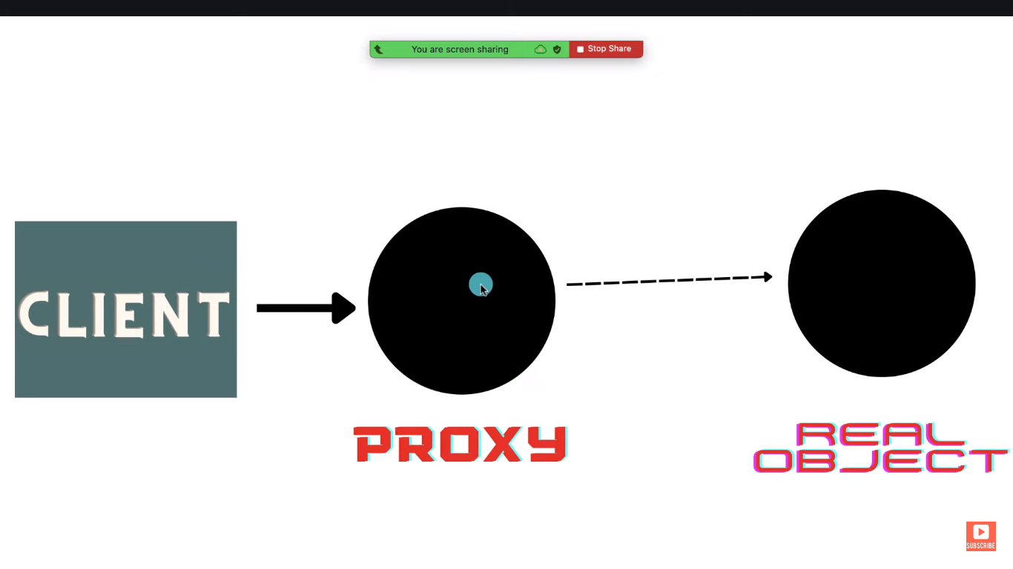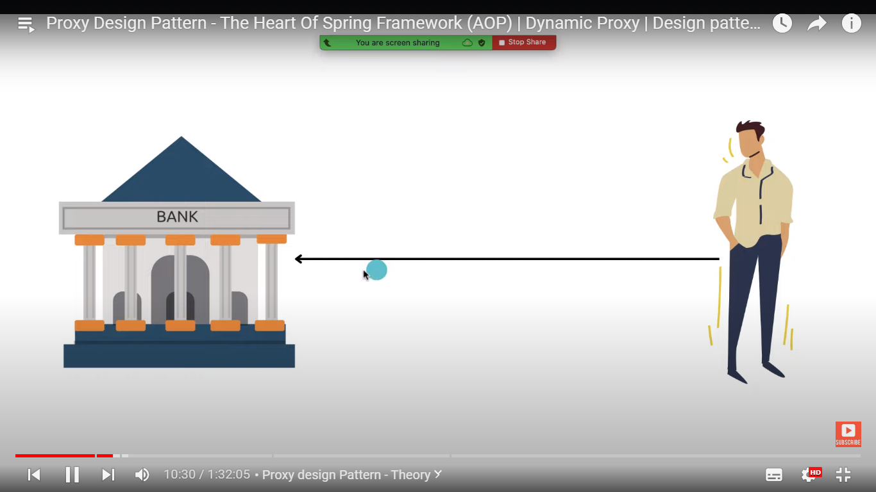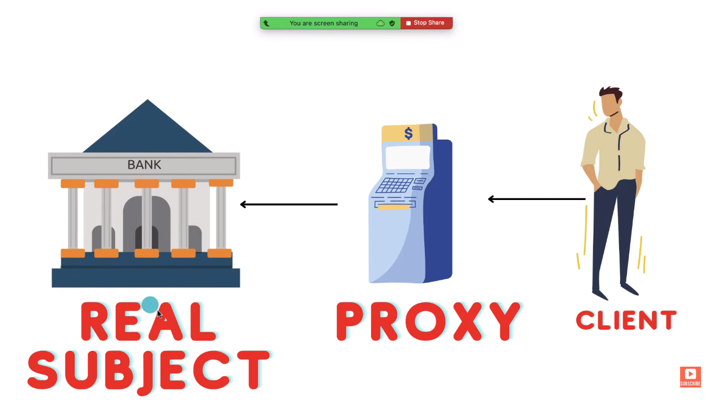



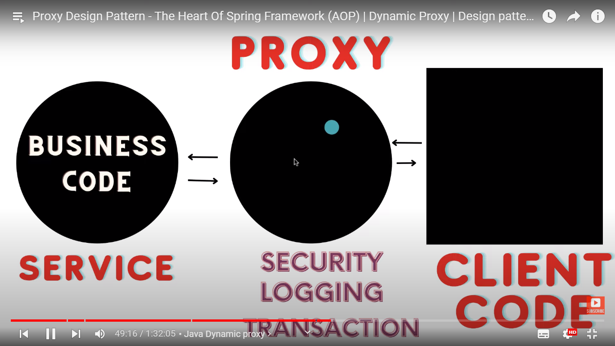

**InvocationHandler Class (Reflection API) provide invoke method which is usedto create Dynamic Proxy of class in Java**

**Also Use Proxy.newProxyInstance to create Proxy Object**

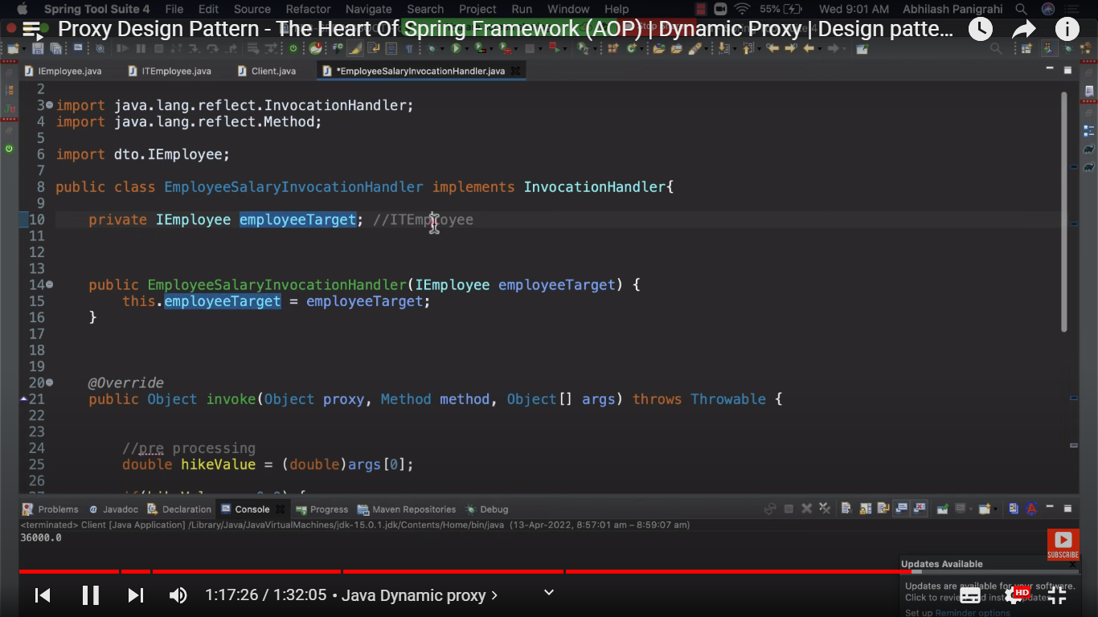

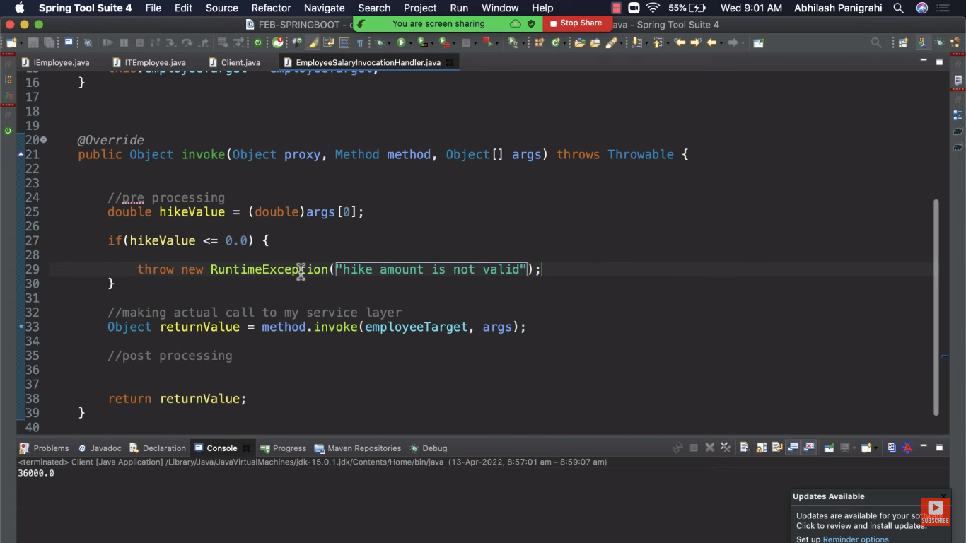

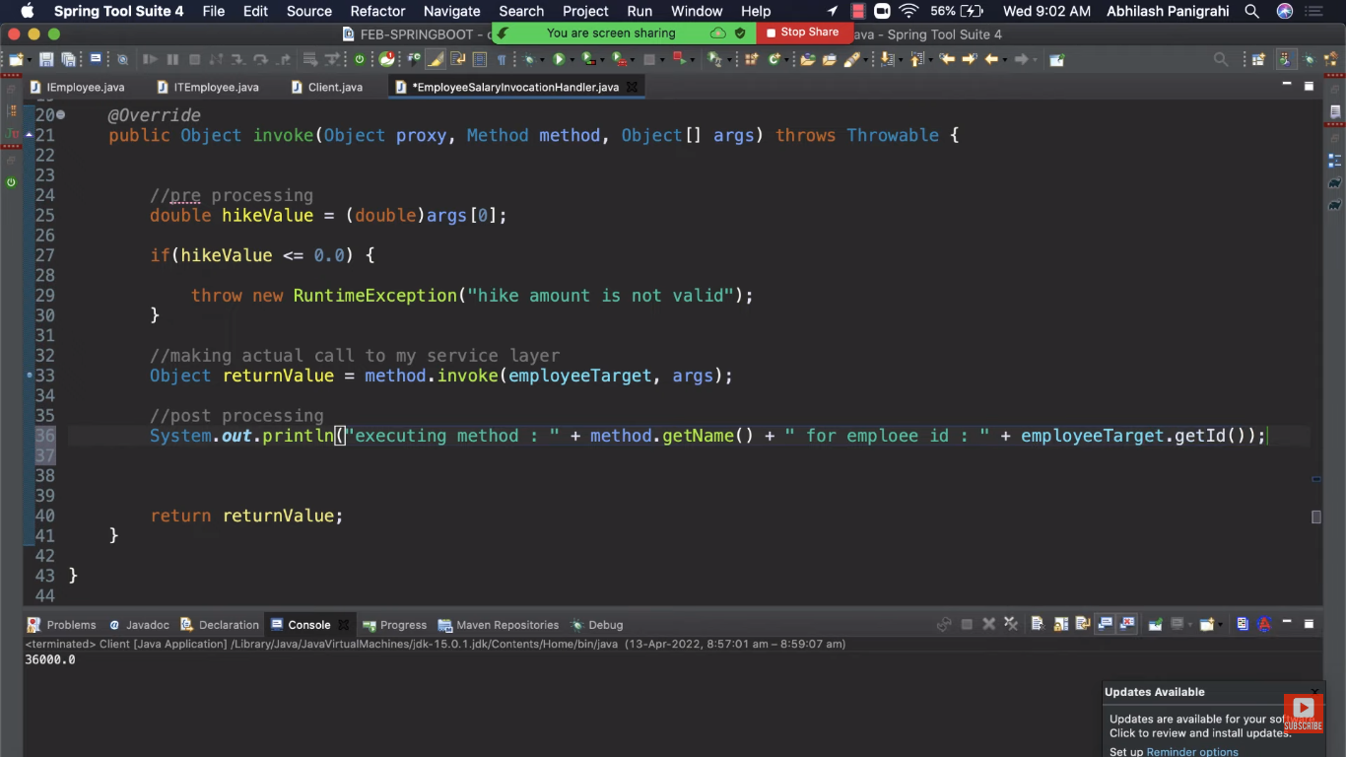

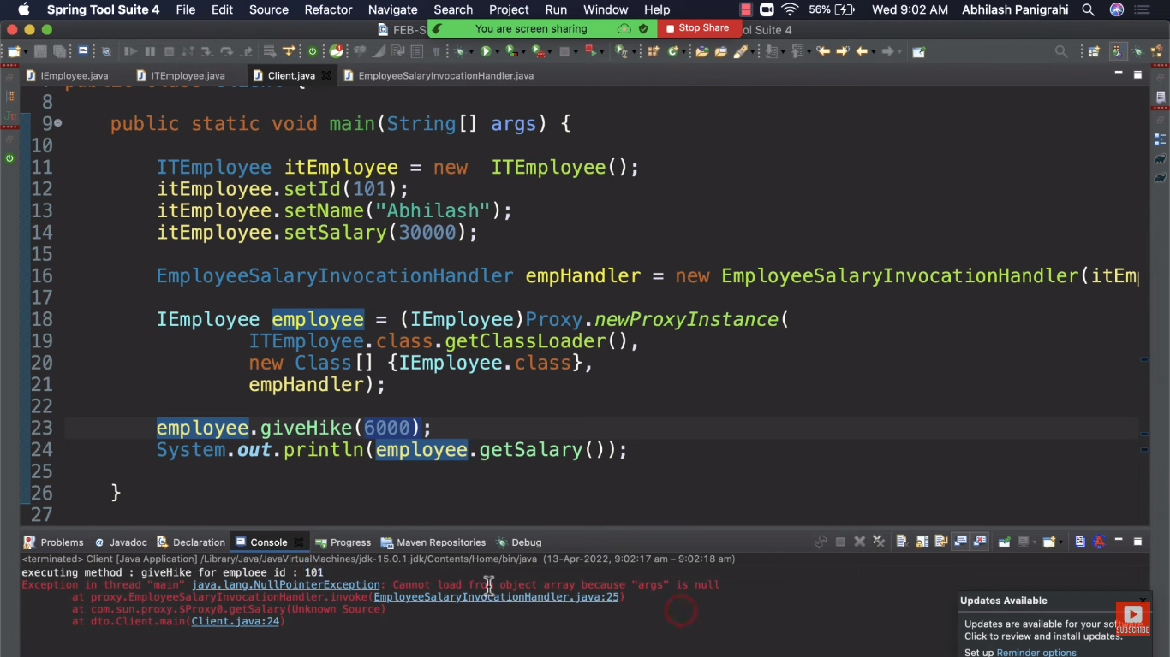

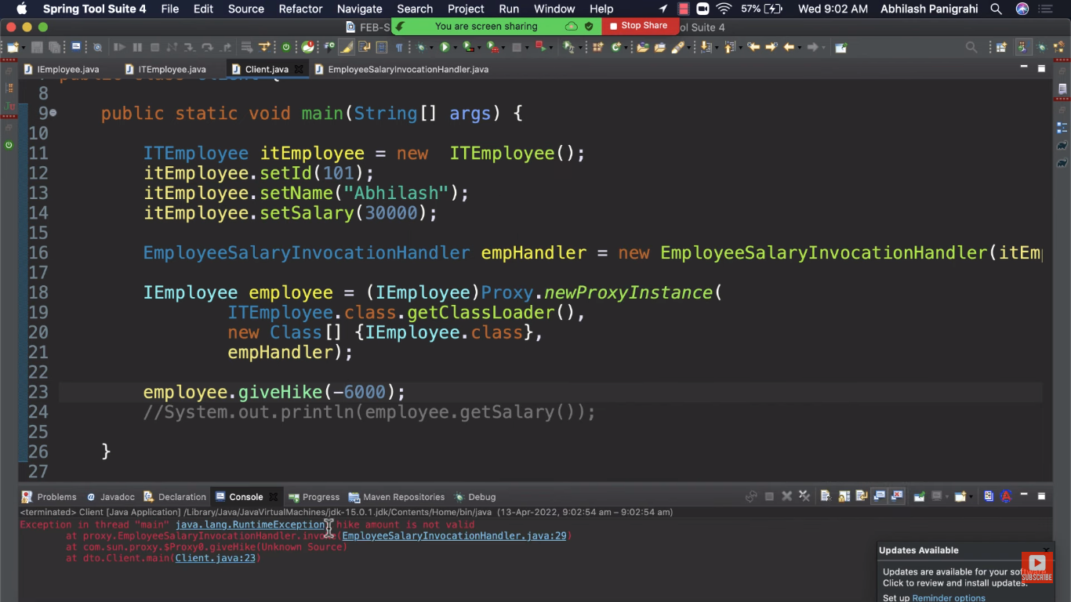 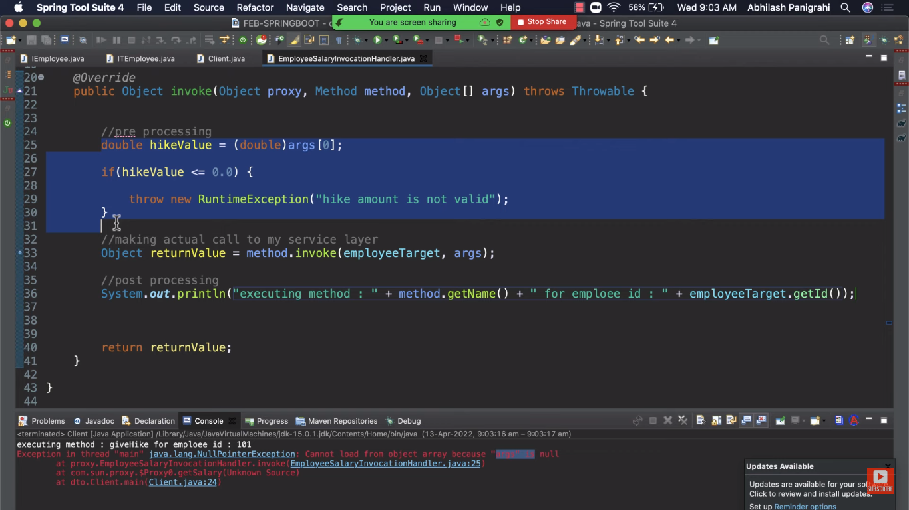 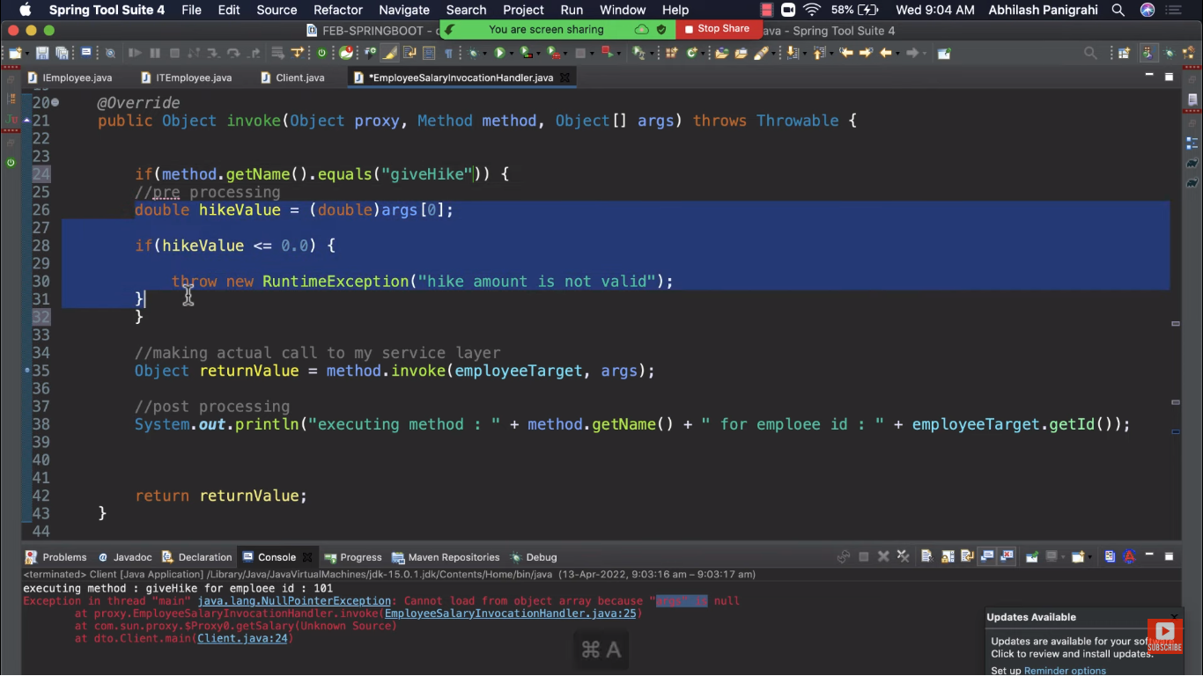

**Transaction Management :**

We need to add @Transactional annotation on service method.

And @**EnableTransactionManagement** on Config class. And @Transactional on method

Then transaction management will work.

And Spring internally creates dynamic proxy to add logic of getConnection, commit rollback , close Connection .

Refer Project at below location

F:\eclipse_workspaces\workspace_hibernate_javabrains\SpringDataJPA

And Video of selenium express.

If we throw any checked exception in saveProductInfo method. And we have @Transactional on that method also. Then spring transaction management will take place

But it will insert all the records ..No rollback by TXN Manager.

If we throw any Runtime Exception , in same method instead of ay checked exception then records will be roll-backed by TXN Manager.

**So rollback feature is only applied to Runtime Exceptions Not Compile time exception.**

If we Add Try catch block to handle runtime exception then also Rollback will not happen

Records will get inserted .If exception is thrown out of themethod of service class then only Spring TXN Manager will rollback it else not.

**There are different options available for @Transactional**

@Transactional(rollbackFor=Exception.class) : If we add this annotation then Exception will be rollbacked .

@Transactional(noRollbackFor=RuntimeException.class) : If we add this annotation then RuntimeExceptions will not be rollbacked

Project information :SpringDataJPA

**Scenario 1:** No Transactional annotation on saveProductInfo as well as saveProduct

And we are throwing exception for record i==7.

So first 7 records are inserted .last 3 records are not inserted

This is not good. not following ACID properties.

**Scenario 2:** added @Transactional annotation on saveProductInfo

Inserted records will be roll-backed. No records in DB.

**Scenario 3**: added @Transactional annotation on saveProductInfo and also added try catch to handle exception.

In this case even though we have transactional annotation , only 7 records are inserted and last 3 records are not inserted .Rollback is not happening. For rollback to happen exception has to propagated outside the method .but we have added try catch block.so its not been propagated.

**Scenario 4**: @Transactional annotation on saveProductInfo and we are throwing Exception (checked exception ) not runtimeException when i==7.

So here also rollback will not happen even though we have added Transactional annotation.

**Scenario 5** : @Transactional annotation on saveProductInfo and we are throwing Exception (checked exception ) not runtimeException when i==7. No Rollback

To make rollback to happen we have to add @Transactional(rollbackFor=Exception.class)

**Scenario 6:** We are throwing Runtime exception for i ==7.So Rollback will happen.

But if we don’t want it to happen then we have to add below on saveProductInfo method.

@Transactional(noRollbackFor=RuntimeException.class)

So now inspite of runtime exception rollback will not happen.we can see first 7 records inserted in DB.

Transaction Propagation :

**REQUIRED Propagation** :

REQUIRED is the default propagation. Spring checks if there is an active transaction, and if nothing exists, it creates a new one. Otherwise, the business logic appends to the currently active transaction

**SUPPORTS Propagation :**

For SUPPORTS, Spring first checks if an active transaction exists. If a transaction exists, then the existing transaction will be used. If there isn't a transaction, it is executed non-transactional

**MANDATORY Propagation**

When the propagation is MANDATORY, if there is an active transaction, then it will be used. If there isn't an active transaction, then Spring throws an exception

**NEVER Propagation :**

For transactional logic with NEVER propagation, Spring throws an exception if there's an active transaction:

**NOT_SUPPORTED Propagation :**

If a current transaction exists, first Spring suspends it, and then the business logic is executed without a transaction

**REQUIRES_NEW Propagation :**

When the propagation is REQUIRES_NEW, Spring suspends the current transaction if it exists, and then creates a new one

For examples check selenium express video

And for code F:\Spring-Transaction-Management_SeleniumExpress\SpringTransactionPropogation

Open F:\eclipse_workspaces\spring_txn_management

**Project information :**

So in the txn_management project we are using AOP to track which methods are getting called and when they are getting called.

We have added 3 classes

1.CallTracker ->It has around advice .so logging statement before and after the methods of repository and service package

2.DataSource Aspect -> Used to track methods of javax.sql.DataSource class

3.ConnectionInvocationHandler -> Dynamic Proxy for ConnectionImpl Object

Nobody can call ConnectionImpl object directly

If any internal call is happening through this object it will go through the proxy

which can log which method is being called (commit/rollback/close).

We have used the proxy in DataSourceAspect class as follows:

Connection con = (Connection) Proxy.newProxyInstance(SQLServerConnection.class.getClassLoader(), new Class[]{Connection.class}, new ConnectionInvocationHandler((Connection) returnValue))

4>In ProductService class we have saveProductInfo method.

You can add / remove @Transactional annotation here

5>In ProductRepo we have saveProduct method where we are making DB call .On this method you can add @Transactional annotation with different propagation levels one by one and test all scenarios to get an idea how it works.

**Different Propagation levels :**

